SOURCE CODE USING JAVA GUI:

Class wedding hall.java:
package wedding_hall_management_system;
import java.awt.*;
import javax.swing.*;
import java.awt.event.ActionEvent;
import java.awt.event.ActionListener;
import java.sql.Connection;
import java.sql.DriverManager;
import java.sql.PreparedStatement;
import java.sql.ResultSet;
import java.sql.Statement;
public class WeddingHall implements ActionListener {
JPanel p=new JPanel();
JFrame f=new JFrame("wedding hall management system");
JLabel username=new JLabel("USERNAME");
JLabel password=new JLabel("PASSWORD");
JLabel label=new JLabel("WELCOME");
JLabel label1=new JLabel("TO");
JLabel label2=new JLabel("LAVENDER SKY HALL");
JLabel l=new JLabel("If you don't have an account then SIGN UP");
JTextField name=new JTextField();
JPasswordField pas=new JPasswordField();
JButton blogin=new JButton("LOGIN");
JButton bsignup=new JButton("SIGN UP");
JButton bexit=new JButton("EXIT");
JPanel panel=new JPanel();
Container con=f.getContentPane();
private static Connection conn;
public static Connection getConnection(){

if (conn != null) { // already open
return conn;
}
String URL="jdbc:oracle:thin:@10.11.0.43:1521:XE";
String user="fa24cs100";
String PASSWORD="oracle";

try {

Class.forName("oracle.jdbc.OracleDriver");
conn = DriverManager.getConnection(URL,user,PASSWORD);
System.out.println("database connection created"); }

catch (Exception ex) {
System.out.println("database connection failed");
JOptionPane.showMessageDialog(null, "Database connection failed: " + ex.getMessage());
}
return conn;
}

WeddingHall(){

con.setLayout(null);
Color lavender = new Color(230, 230, 250);
con.setBackground(new Color(230, 230, 250));
JComponent image1= new JComponent() {
Image img = new ImageIcon("image10.jpg").getImage();

@Override
protected void paintComponent(Graphics g) {
super.paintComponent(g);
g.drawImage(img, 0, 0, getWidth(), getHeight(), this);
}
};
JComponent image2 = new JComponent() {
Image img = new ImageIcon("image8.jpg").getImage();

@Override
protected void paintComponent(Graphics g) {
super.paintComponent(g);
g.drawImage(img, 0, 0, getWidth(), getHeight(), this);
}
};
f.setSize(1500,1500);
image1.setBounds(700, 0, 670, 750);
con.add(image1);
image2.setBounds(72, 10, 520, 300);
con.add(image2);

label.setBounds(210,20,500,100);
con.add(label);
Font customFont = new Font("Serif", Font.BOLD, 40);
label.setFont(customFont);
label.setForeground(new Color(100, 50, 150));
con.setComponentZOrder(label, 0);

label1.setBounds(290,80,500,100);
con.add(label1);
Font customFont1 = new Font("Serif", Font.BOLD, 40);
label1.setFont(customFont1);
label1.setForeground(new Color(100, 50, 150));
con.setComponentZOrder(label1, 0);

label2.setBounds(125,150,500,100);
con.add(label2);
Font customFont2 = new Font("Serif", Font.BOLD|Font.ITALIC, 40);
label2.setFont(customFont2);
label2.setForeground(new Color(100, 50, 150));
con.setComponentZOrder(label2, 0);

username.setBounds(20,390,200,30);
con.add(username);

password.setBounds(20, 460, 200, 30);
con.add(password);

name.setBounds(250,390,300,40);
con.add(name);
name.addActionListener(this);

pas.setBounds(250,460,300,40);
con.add(pas);
pas.addActionListener(this);

l.setBounds(180,530,400,40);
con.add(l);

Font bFont = new Font("Serif", Font.BOLD, 20);

bexit.setBounds(20,600,150,30);
bexit.setBackground(new Color(255, 240, 245));
bexit.setFont(bFont);
con.add(bexit);
bexit.addActionListener(this);

bsignup.setBounds(210,600,150,30);
bsignup.setBackground(new Color(255, 240, 245));
bsignup.setFont(bFont);
con.add(bsignup);
bsignup.addActionListener(this);

blogin.setBounds(400,600,150,30);
blogin.setBackground(new Color(255, 240, 245));
blogin.setFont(bFont);
con.add(blogin);
blogin.addActionListener(this);

f.setDefaultCloseOperation(JFrame.EXIT_ON_CLOSE);
f.setVisible(true);

}

public static void main(String[] args) {
WeddingHall wed=new WeddingHall();
}

@Override
public void actionPerformed(ActionEvent e) {
if(e.getSource()==blogin) {
String uname=name.getText();
String pswd= new String(pas.getPassword());
try {
PreparedStatement pst = conn.prepareStatement(
"SELECT * FROM users WHERE username = ? AND password = ?"
);
pst.setString(1, uname);
pst.setString(2, pswd);
ResultSet rs = pst.executeQuery();

if (rs.next()) {
JOptionPane.showMessageDialog(null, "Login Successful!");
new MainMenu();
f.dispose();
} else {
JOptionPane.showMessageDialog(null, "Invalid username or password.");
}
} catch (Exception ex) {
JOptionPane.showMessageDialog(null, "Login failed: " + ex.getMessage());
}
}

else if (e.getSource() == bsignup) {
JOptionPane.showMessageDialog(null, "Redirecting to sign up...");
new SignUp(); // open the sign-up window
f.dispose();
}
else if (e.getSource() == bexit) {
int confirm = JOptionPane.showConfirmDialog(null, "Are you sure you want to exit?");
if (confirm == JOptionPane.YES_OPTION) {
System.exit(0);
}
}

}

}
OUTPUT:
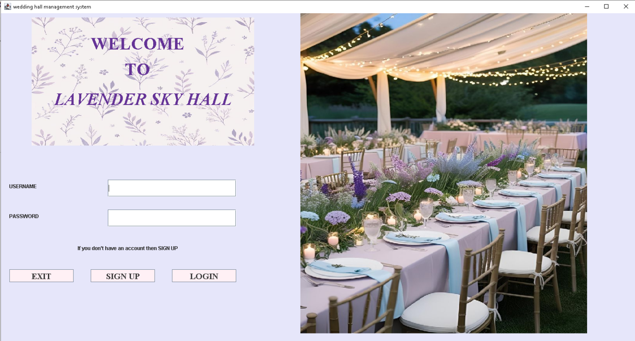
Code signup.java:
package wedding_hall_management_system;

import javax.swing.*;
import java.awt.*;
import java.awt.event.*;
import java.sql.*;

public class SignUp implements ActionListener {
JFrame f=new JFrame();
JPanel p=new JPanel();
JTextField username = new JTextField();
JPasswordField passwordField = new JPasswordField();
JButton signUpButton = new JButton("SIGN UP");
JButton backButton = new JButton("BACK");
JRadioButton male=new JRadioButton("MALE");
JRadioButton female=new JRadioButton("FEMALE");
JRadioButton other=new JRadioButton("OTHER");
ButtonGroup bgroup=new ButtonGroup();
Container c=f.getContentPane();
Connection conn;

public SignUp() {
f.setTitle("Sign Up - Lavender Sky Hall");
f.setDefaultCloseOperation(JFrame.EXIT_ON_CLOSE);
f.setLayout(null);
f.setSize(600,600);
f.setLocationRelativeTo(null);
c.setLayout(null);
c.setBackground(new Color(230, 230, 250));

JLabel titleLabel = new JLabel("CREATE A NEW ACCOUNT");
titleLabel.setBounds(70, 30, 400, 30);
titleLabel.setFont(new Font("Baskerville", Font.BOLD|Font.ITALIC, 25));
titleLabel.setForeground(new Color(148, 112, 196));
c.add(titleLabel);

JLabel userLabel = new JLabel("Username:");
userLabel.setBounds(50, 100, 100, 30);
c.add(userLabel);

username.setBounds(160, 100, 250, 30);
c.add(username);

JLabel passLabel = new JLabel("Password:");
passLabel.setBounds(50, 150, 100, 30);
c.add(passLabel);

JLabel genderLabel=new JLabel("Gender:");
genderLabel.setBounds(50,190,100,30);
c.add(genderLabel);

passwordField.setBounds(160, 150, 250, 30);
c.add(passwordField);

signUpButton.setBounds(160, 270, 100, 30);
backButton.setBounds(280, 270, 100, 30);
c.add(signUpButton);
c.add(backButton);

male.setBounds(160,190,100,50);
female.setBounds(270,190,100,50);
other.setBounds(380,190,100,50);

bgroup.add(male);
bgroup.add(female);
bgroup.add(other);

c.add(male);
c.add(female);
c.add(other);

signUpButton.addActionListener(this);
backButton.addActionListener(this);

male.addActionListener(this);
female.addActionListener(this);
other.addActionListener(this);

f.setVisible(true);
}

@Override
public void actionPerformed(ActionEvent e) {
if (e.getSource() == signUpButton) {

String uname = username.getText().trim();
String pswd = new String(passwordField.getPassword());
String gender="default";
if(male.isSelected()) {
gender="male";
}
else if(female.isSelected()) {
gender="female";
}
else if(other.isSelected()) {
gender="other";
}
if (uname.isEmpty() || pswd.isEmpty()||gender.isEmpty()) {
JOptionPane.showMessageDialog(backButton, this, "Please fill in all fields.", 0);
return;
}

try {
conn = WeddingHall.getConnection();
PreparedStatement checkUser = conn.prepareStatement("SELECT username FROM users WHERE username = ?");
checkUser.setString(1, uname);
ResultSet rs = checkUser.executeQuery();
if (rs.next()) {
JOptionPane.showMessageDialog(backButton, this, "Username already exists.", 0);
} else {
PreparedStatement insertUser = conn.prepareStatement("INSERT INTO users (username, password,gender) VALUES (?, ?, ?)");
insertUser.setString(1, uname);
insertUser.setString(2, pswd); // Replace with hashed password in production
insertUser.setString(3, gender);
insertUser.executeUpdate();
JOptionPane.showMessageDialog(backButton, this, "Account created successfully!", 0);
f. dispose();
new WeddingHall(); // Go back to login
}
} catch (Exception ex) {
JOptionPane.showMessageDialog(backButton, this, "Error creating account: " + ex.getMessage(), 0);
}

} else if (e.getSource() == backButton) {
f.dispose();
new WeddingHall(); // Back to login screen
}
}
}
OUTPUT:
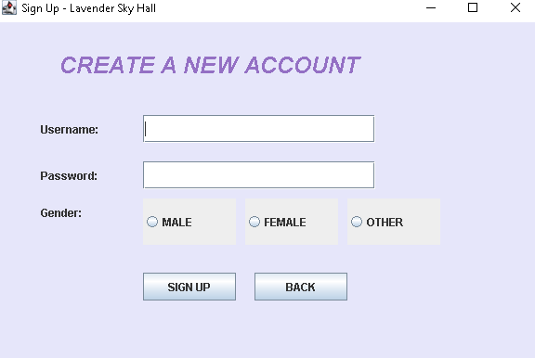
Code main menu.java:
package wedding_hall_management_system;

import javax.swing.*;
import java.awt.*;
import java.awt.event.*;

public class MainMenu implements ActionListener {
JFrame fr=new JFrame();
JButton bookingButton = new JButton("BOOKING");
JButton menuButton = new JButton("MENU");
JButton paymentButton = new JButton("PAYMENT");
JButton plannerButton = new JButton("PLANNER");
JLabel title=new JLabel("LAVENDER SKY HALL");
JPanel p=new JPanel();
public MainMenu() {
fr.setTitle("Lavender Sky Hall - Main Menu");
fr.setSize(1500, 1500);
fr.setDefaultCloseOperation(JFrame.EXIT_ON_CLOSE);
fr.setLocationRelativeTo(null); // center window
JComponent image3= new JComponent() {
Image img = new ImageIcon("image11.jpg").getImage();

@Override
protected void paintComponent(Graphics g) {
super.paintComponent(g);
g.drawImage(img, 0, 0, getWidth(), getHeight(), this);
}
};
JComponent image4= new JComponent() {
Image img = new ImageIcon("image12.jpg").getImage();

@Override
protected void paintComponent(Graphics g) {
super.paintComponent(g);
g.drawImage(img, 0, 0, getWidth(), getHeight(), this);
}
};

JComponent image5= new JComponent() {
Image img = new ImageIcon("image17.jpg").getImage();

@Override
protected void paintComponent(Graphics g) {
super.paintComponent(g);
g.drawImage(img, 0, 0, getWidth(), getHeight(), this);
}
};

JComponent image6= new JComponent() {
Image img = new ImageIcon("image14.jpg").getImage();

@Override
protected void paintComponent(Graphics g) {
super.paintComponent(g);
g.drawImage(img, 0, 0, getWidth(), getHeight(), this);
}
};

JComponent image8= new JComponent() {
Image img = new ImageIcon("image16.png").getImage();

@Override
protected void paintComponent(Graphics g) {
super.paintComponent(g);
g.drawImage(img, 0, 0, getWidth(), getHeight(), this);
}
};

JComponent image9= new JComponent() {
Image img = new ImageIcon("image16.png").getImage();

@Override
protected void paintComponent(Graphics g) {
super.paintComponent(g);
g.drawImage(img, 0, 0, getWidth(), getHeight(), this);
}
};

Container con=fr.getContentPane();
con.setBackground(new Color(230,230,250));
con.setLayout(null);

image3.setBounds(0, 0, 250, 250);
con.add(image3);

image4.setBounds(0,255, 200, 300);
con.add(image4);

image5.setBounds(0,560, 250, 250);
con.add(image5);

image6.setBounds(205,255, 50, 300);
con.add(image6);

image8.setBounds(845,440, 500, 400);
con.add(image8);

image9.setBounds(300,440, 560, 400);
con.add(image9);

title.setBounds(465,40,590,100);
con.add(title);
Font customFont2 = new Font("Serif", Font.BOLD|Font.ITALIC,55);
title.setFont(customFont2);
title.setForeground(new Color(100, 50, 150));

// Customize buttons: larger size, white background, bigger font
Font buttonFont = new Font("Gabriola", Font.BOLD, 35);

bookingButton.setBounds(500,200,200,100);
bookingButton.setBackground(new Color(255,240,245));
bookingButton.setFont(buttonFont);
con.add(bookingButton);
bookingButton.addActionListener(this);

menuButton.setBounds(800,200,200,100);
menuButton.setBackground(new Color(255,240, 245));
menuButton.setFont(buttonFont);
con.add(menuButton);
menuButton.addActionListener(this);

paymentButton.setBounds(500,400,200,100);
paymentButton.setBackground(new Color(255, 240, 245));
paymentButton.setFont(buttonFont);
con.add(paymentButton);
paymentButton.addActionListener(this);

plannerButton.setBounds(800,400,200,100);
plannerButton.setBackground(new Color(255, 240, 245));
plannerButton.setFont(buttonFont);
con.add(plannerButton);
plannerButton.addActionListener(this);

fr.setVisible(true);
}

@Override
public void actionPerformed(ActionEvent e) {
if (e.getSource() == bookingButton) {
new BookingForm();
} else if (e.getSource() == paymentButton) {
new PaymentForm();
} else if (e.getSource() == plannerButton) {
new PlannerForm();
}
else if(e.getSource()==menuButton) {
new MenuForm();
}
}
public static void main (String[] args) {
MainMenu m=new MainMenu();
}
}
OUTPUT:
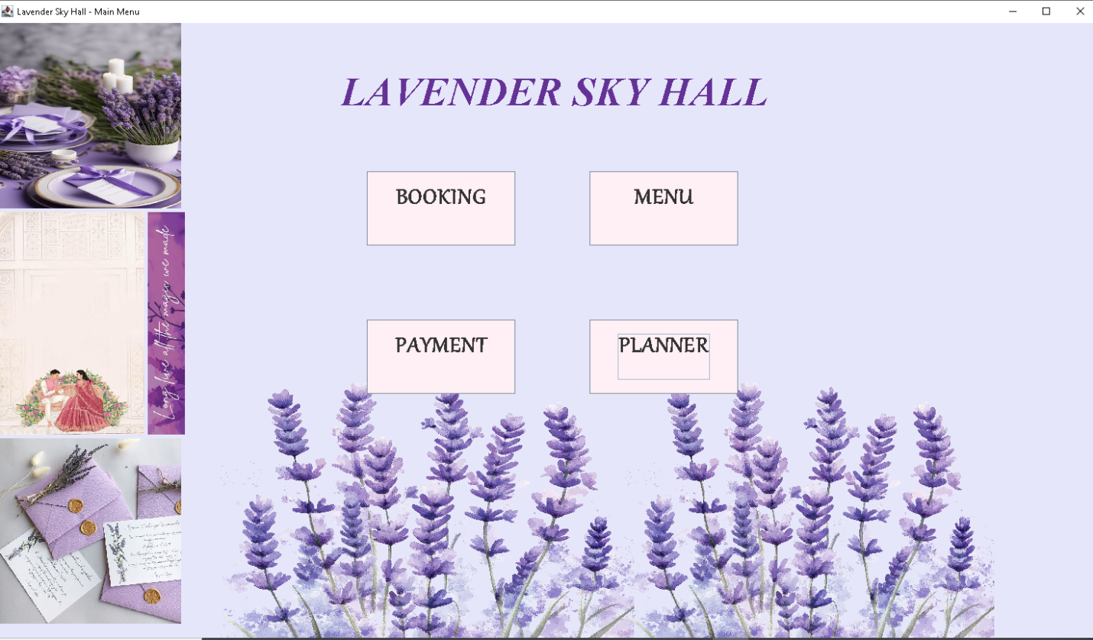
Code Bookinf form.java:
package wedding_hall_management_system;
import javax.swing.*;
import javax.swing.table.DefaultTableModel;

import java.awt.*;
import java.awt.event.*;
import java.sql.Connection;
import java.sql.PreparedStatement;
import java.sql.ResultSet;
import java.util.Vector;
import java.sql.*;

public class BookingForm extends JFrame implements ActionListener {
JTextField bookingIdField = new JTextField();
JTextField bookingDateField = new JTextField(); // You can use JDatePicker in real projects
JComboBox<String> bookingTypeCombo = new JComboBox<>(new String[] {
"Wedding", "Reception", "Engagement", "Birthday", "Other"
});

JButton submitButton = new JButton("Submit");
JButton viewButton = new JButton("View");
private DefaultTableModel tableModel=new DefaultTableModel();
private JTable bookingTable=new JTable(tableModel);
JScrollPane scroll = new JScrollPane(bookingTable);
Connection conn;
public BookingForm() {
setTitle("Booking Form - Lavender Sky Hall");
setSize(1000, 1000);
setLocationRelativeTo(null);
setDefaultCloseOperation(JFrame.DISPOSE_ON_CLOSE); // Only close this window

getContentPane().setBackground(new Color(230, 230, 250));
setLayout(new GridBagLayout());
GridBagConstraints gbc = new GridBagConstraints();
gbc.insets = new Insets(15, 15, 15, 15);
gbc.anchor = GridBagConstraints.WEST;

Font labelFont = new Font("Serif", Font.BOLD, 16);

// Booking ID
gbc.gridx = 0;
gbc.gridy = 0;
JLabel idLabel = new JLabel("Booking ID:");
idLabel.setFont(labelFont);
add(idLabel, gbc);

gbc.gridx = 1;
bookingIdField.setPreferredSize(new Dimension(200, 25));
add(bookingIdField, gbc);

// Booking Date
gbc.gridx = 0;
gbc.gridy = 1;
JLabel dateLabel = new JLabel("Booking Date:");
dateLabel.setFont(labelFont);
add(dateLabel, gbc);

gbc.gridx = 1;
bookingDateField.setPreferredSize(new Dimension(200, 25));
bookingDateField.setToolTipText("Format: YYYY-MM-DD");
add(bookingDateField, gbc);

// Booking Type
gbc.gridx = 0;
gbc.gridy = 2;
JLabel typeLabel = new JLabel("Booking Type:");
typeLabel.setFont(labelFont);
add(typeLabel, gbc);

gbc.gridx = 1;
bookingTypeCombo.setPreferredSize(new Dimension(200, 25));
add(bookingTypeCombo, gbc);

// Submit button
gbc.gridx = 0;
gbc.gridy = 3;
submitButton.setPreferredSize(new Dimension(100, 30));
submitButton.addActionListener(this);
add(submitButton, gbc);

gbc.gridx = 1;
gbc.gridy = 3;
viewButton.setPreferredSize(new Dimension(100, 30));
viewButton.addActionListener(this);
add(viewButton, gbc);

bookingTable.setFillsViewportHeight(true);

gbc.gridx = 0;
gbc.gridy = 4; // next free row
gbc.gridwidth = 2; // span both columns
gbc.weightx = 1;
gbc.weighty = 1;
gbc.fill = GridBagConstraints.BOTH;
add(scroll, gbc);

setVisible(true);
}

@Override
public void actionPerformed(ActionEvent e) {
String id = bookingIdField.getText().trim();
String date = bookingDateField.getText().trim();
String type = bookingTypeCombo.getSelectedItem().toString();

if (id.isEmpty() || date.isEmpty()) {
JOptionPane.showMessageDialog(this, "Please fill in all fields.");
} if(e.getSource()==submitButton) {
System.out.println("submit button is pressed");
try {
conn = WeddingHall.getConnection();
System.out.println("Connection: " + conn);

try( PreparedStatement checkUser = conn.prepareStatement("SELECT BOOKING_DATE FROM booking WHERE BOOKING_DATE= ?")){
checkUser.setDate(1, java.sql.Date.valueOf(date));
ResultSet rs = checkUser.executeQuery();
if (rs.next()) {
JOptionPane.showMessageDialog(null, this, "Booking already made at that date.Choose a different date.", 0);
return;
}
}
try(PreparedStatement inStmt = conn.prepareStatement("INSERT INTO BOOKING (BOOKING_ID,BOOKING_DATE,BOOKING_TYPE) VALUES (?, ?, ?)"))
{
inStmt.setInt(1, Integer.parseInt(id));
inStmt.setDate(2, java.sql.Date.valueOf(date));
inStmt.setString(3, type);
inStmt.executeUpdate();
JOptionPane.showMessageDialog(null, this, "Booking created successfully!", 0);
dispose();
new MainMenu();
}

}
catch (Exception ex) {
ex.printStackTrace();
JOptionPane.showMessageDialog(null, this, "Error creating booking: " + ex.getMessage(), 0);
}
}
if(e.getSource()==viewButton) {
try (PreparedStatement selectStmt= conn.prepareStatement(
"SELECT * FROM Booking_view");
ResultSet rs = selectStmt.executeQuery()) {

ResultSetMetaData md = rs.getMetaData();
int cols = md.getColumnCount();

// Build column list
Vector<String> colNames = new Vector<>();
for (int i = 1; i <= cols; i++) {
colNames.add(md.getColumnName(i));
}

// Build rows
Vector<Vector<Object>> rows = new Vector<>();
while (rs.next()) {
Vector<Object> row = new Vector<>(cols);
for (int i = 1; i <= cols; i++) {
row.add(rs.getObject(i));
}
rows.add(row);
}

tableModel.setDataVector(rows, colNames); // instant refresh

}

catch(Exception ex) {
JOptionPane.showMessageDialog(null, this, "Error viewing booking: " + ex.getMessage(), 0);

}
}
}
public static void main (String[] args) {
BookingForm book=new BookingForm();
}
}
OUTPUT:
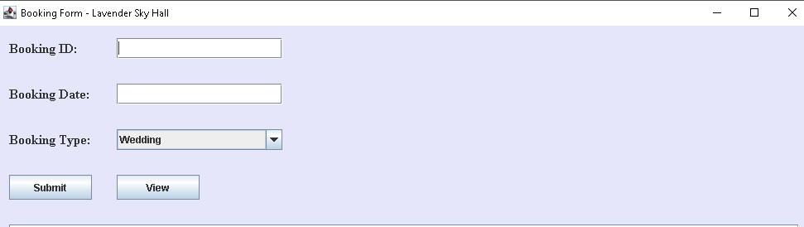
Code Planner.java:
package wedding_hall_management_system;

import javax.swing.*;
import javax.swing.table.DefaultTableModel;

import java.awt.*;
import java.awt.event.*;
import java.sql.Connection;
import java.sql.PreparedStatement;
import java.sql.ResultSet;
import java.sql.ResultSetMetaData;
import java.util.Vector;

public class PlannerForm extends JFrame implements ActionListener {
JTextField plannerIdField = new JTextField();
JTextField nameField = new JTextField();
JTextField emailField = new JTextField();
JTextField contactField = new JTextField();
JButton submitButton = new JButton("Submit");
JButton viewButton = new JButton("View");
private DefaultTableModel table=new DefaultTableModel();
private JTable plannerTable=new JTable(table);
JScrollPane scroll = new JScrollPane(plannerTable);
Connection conn;
public PlannerForm() {
setTitle("Planner Form - Lavender Sky Hall");
setSize(1000, 1000);
setLocationRelativeTo(null); // center the window
setDefaultCloseOperation(JFrame.DISPOSE_ON_CLOSE);
getContentPane().setBackground(new Color(230, 230, 250)); // Lavender

setLayout(new GridBagLayout());
GridBagConstraints gbc = new GridBagConstraints();
gbc.insets = new Insets(12, 12, 12, 12);
gbc.anchor = GridBagConstraints.WEST;

Font labelFont = new Font("Serif", Font.BOLD, 16);

// Planner ID
gbc.gridx = 0;
gbc.gridy = 0;
JLabel idLabel = new JLabel("Planner ID:");
idLabel.setFont(labelFont);
add(idLabel, gbc);

gbc.gridx = 1;
plannerIdField.setPreferredSize(new Dimension(220, 25));
add(plannerIdField, gbc);

// Name
gbc.gridx = 0;
gbc.gridy = 1;
JLabel nameLabel = new JLabel("Name:");
nameLabel.setFont(labelFont);
add(nameLabel, gbc);

gbc.gridx = 1;
nameField.setPreferredSize(new Dimension(220, 25));
add(nameField, gbc);

// Email
gbc.gridx = 0;
gbc.gridy = 2;
JLabel emailLabel = new JLabel("Email:");
emailLabel.setFont(labelFont);
add(emailLabel, gbc);

gbc.gridx = 1;
emailField.setPreferredSize(new Dimension(220, 25));
add(emailField, gbc);

// Contact Number
gbc.gridx = 0;
gbc.gridy = 3;
JLabel contactLabel = new JLabel("Contact No.:");
contactLabel.setFont(labelFont);
add(contactLabel, gbc);

gbc.gridx = 1;
contactField.setPreferredSize(new Dimension(220, 25));
add(contactField, gbc);

// Submit Button
gbc.gridx = 0;
gbc.gridy = 4;
submitButton.setPreferredSize(new Dimension(100, 30));
submitButton.addActionListener(this);
add(submitButton, gbc);

gbc.gridx = 1;
gbc.gridy = 4;
viewButton.setPreferredSize(new Dimension(100, 30));
viewButton.addActionListener(this);
add(viewButton, gbc);

plannerTable.setFillsViewportHeight(true);

gbc.gridx = 0;
gbc.gridy = 5; // next free row
gbc.gridwidth = 2; // span both columns
gbc.weightx = 1;
gbc.weighty = 1;
gbc.fill = GridBagConstraints.BOTH;
add(scroll, gbc);

setVisible(true);
}

@Override
public void actionPerformed(ActionEvent e) {
String id = plannerIdField.getText().trim();
String name = nameField.getText().trim();
String email = emailField.getText().trim();
String contact = contactField.getText().trim();

if (id.isEmpty() || name.isEmpty() || email.isEmpty() || contact.isEmpty()) {
JOptionPane.showMessageDialog(this, "Please fill in all fields.");
} else if (!contact.matches("\\d{10}")) {
JOptionPane.showMessageDialog(this, "Please enter a valid 10-digit contact number.");
} else if (!email.contains("@") || !email.contains(".")) {
JOptionPane.showMessageDialog(this, "Please enter a valid email address.");
}
if(e.getSource()==submitButton) {

try {
conn = WeddingHall.getConnection();
try (PreparedStatement insertUser = conn.prepareStatement("INSERT INTO planner (planner_id,name,e_mail,contact_no) VALUES (?, ?, ?, ?)"))
{
insertUser.setString(1, id);
insertUser.setString(2, name);
insertUser.setString(3, email);
insertUser.setString(4, contact);
insertUser.executeUpdate();
JOptionPane.showMessageDialog(null, this, "Planner recorded successfully!", 0);
dispose();
new MainMenu();
}
}
catch (Exception ex) {
JOptionPane.showMessageDialog(null, this, "Error recording planner: " + ex.getMessage(), 0);
}
}
if(e.getSource()==viewButton) {
try (PreparedStatement selectStmt= conn.prepareStatement(
"SELECT * FROM Planner_view");
ResultSet rs = selectStmt.executeQuery()) {

ResultSetMetaData md = rs.getMetaData();
int cols = md.getColumnCount();

// Build column list
Vector<String> colNames = new Vector<>();
for (int i = 1; i <= cols; i++) {
colNames.add(md.getColumnName(i));
}

// Build rows
Vector<Vector<Object>> rows = new Vector<>();
while (rs.next()) {
Vector<Object> row = new Vector<>(cols);
for (int i = 1; i <= cols; i++) {
row.add(rs.getObject(i));
}
rows.add(row);
}

table.setDataVector(rows, colNames); // instant refresh

}

catch(Exception ex) {
JOptionPane.showMessageDialog(null, this, "Error viewing booking: " + ex.getMessage(), 0);

}
}
}

public static void main(String[] args) {
// TODO Auto-generated method stub
PlannerForm plan=new PlannerForm();
}

}
OUTPUT:
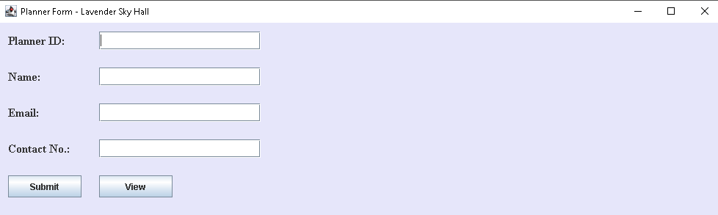
Code payment.java:
package wedding_hall_management_system;

import javax.swing.*;
import javax.swing.table.DefaultTableModel;

import java.awt.*;
import java.awt.event.*;
import java.sql.Connection;
import java.sql.PreparedStatement;
import java.sql.ResultSet;
import java.sql.ResultSetMetaData;
import java.util.Vector;

public class PaymentForm extends JFrame implements ActionListener {
JTextField paymentIdField = new JTextField();
JTextField amountField = new JTextField();
JTextField dateField = new JTextField(); // Simple text field for date
JRadioButton cash=new JRadioButton("CASH");
JRadioButton card=new JRadioButton("CARD");
JRadioButton other=new JRadioButton("OTHER");
ButtonGroup bgroup=new ButtonGroup();
JButton submitButton = new JButton("Submit");
JButton viewButton = new JButton("View");
private DefaultTableModel table2=new DefaultTableModel();
private JTable paymentTable=new JTable(table2);
JScrollPane scroll = new JScrollPane(paymentTable);
Connection conn;

public PaymentForm() {
setTitle("Payment Form - Lavender Sky Hall");
setSize(1000, 1000);
setLocationRelativeTo(null); // center the window
setDefaultCloseOperation(JFrame.DISPOSE_ON_CLOSE);

getContentPane().setBackground(new Color(230, 230, 250)); // lavender background
setLayout(new GridBagLayout());
GridBagConstraints gbc = new GridBagConstraints();
gbc.insets = new Insets(12, 12, 12, 12);
gbc.anchor = GridBagConstraints.WEST;

Font labelFont = new Font("Serif", Font.BOLD, 16);

// Payment ID
gbc.gridx = 0;
gbc.gridy = 0;
JLabel idLabel = new JLabel("Payment ID:");
idLabel.setFont(labelFont);
add(idLabel, gbc);

gbc.gridx = 1;
paymentIdField.setPreferredSize(new Dimension(200, 25));
gbc.fill = GridBagConstraints.HORIZONTAL;
add(paymentIdField, gbc);

gbc.fill = GridBagConstraints.NONE;

// Amount
gbc.gridx = 0;
gbc.gridy = 1;
JLabel amountLabel = new JLabel("Amount:");
amountLabel.setFont(labelFont);
add(amountLabel, gbc);

gbc.gridx = 1;
amountField.setPreferredSize(new Dimension(200, 25));
gbc.fill = GridBagConstraints.HORIZONTAL;
add(amountField, gbc);

gbc.fill = GridBagConstraints.NONE;

// Date
gbc.gridx = 0;
gbc.gridy = 2;
JLabel dateLabel = new JLabel("Date:");
dateLabel.setFont(labelFont);
add(dateLabel, gbc);

gbc.gridx = 1;
dateField.setPreferredSize(new Dimension(200, 25));
dateField.setToolTipText("Format: YYYY-MM-DD");
gbc.fill = GridBagConstraints.HORIZONTAL;
add(dateField, gbc);

gbc.fill = GridBagConstraints.NONE;

gbc.gridx = 0;
gbc.gridy = 3;
JLabel typeLabel = new JLabel("Payment_Type:");
typeLabel.setFont(labelFont);
add(typeLabel, gbc);

gbc.gridx=1;
gbc.gridy=3;
bgroup.add(cash);
add(cash,gbc);
gbc.gridy=4;
bgroup.add(card);
add(card,gbc);
gbc.gridy=5;
bgroup.add(other);
add(other,gbc);

// Submit button
gbc.gridx = 0;
gbc.gridy = 6;
submitButton.setPreferredSize(new Dimension(100, 30));
submitButton.addActionListener(this);
add(submitButton, gbc);

gbc.gridx = 1;
gbc.gridy = 6;
viewButton.setPreferredSize(new Dimension(100, 30));
viewButton.addActionListener(this);
add(viewButton, gbc);

paymentTable.setFillsViewportHeight(true);

gbc.gridx = 0;
gbc.gridy = 7; // next free row
gbc.gridwidth = 2; // span both columns
gbc.weightx = 1;
gbc.weighty = 1;
gbc.fill = GridBagConstraints.BOTH;
add(scroll, gbc);

setVisible(true);
}

@Override
public void actionPerformed(ActionEvent e) {
String id = paymentIdField.getText().trim();
String amount = amountField.getText().trim();
String date = dateField.getText().trim();
String type="default";
if(cash.isSelected()) {
type="cash";
}
else if(card.isSelected()) {
type="female";
}
else if(other.isSelected()) {
type="other";
}
if (id.isEmpty() || amount.isEmpty() || date.isEmpty()||type.isEmpty()) {
JOptionPane.showMessageDialog(this, "Please fill in all fields.");
return;
}

try {
double amt = Double.parseDouble(amount); // Validate amount
JOptionPane.showMessageDialog(this,
"Payment amount is valid");

} catch (NumberFormatException ex) {
JOptionPane.showMessageDialog(this, "Please enter a valid numeric amount.");
}
if(e.getSource()==submitButton) {
try {
conn = WeddingHall.getConnection();
try
(PreparedStatement checkUser = conn.prepareStatement("SELECT PAYMENT_ID FROM PAYMENT WHERE PAYMENT_ID = ?")){
checkUser.setString(1, id);
ResultSet rs = checkUser.executeQuery();
if (rs.next()) {
JOptionPane.showMessageDialog(null, this, "id already exists.", 0);
}
}
try(
PreparedStatement insertUser = conn.prepareStatement("INSERT INTO payment (payment_id,amount,date,paymeny_type) VALUES (?, ?, ?, ?,)"))
{ insertUser.setString(1, id);
insertUser.setString(2, amount);
insertUser.setDate(3, java.sql.Date.valueOf(date));
insertUser.setString(4, type);
insertUser.executeUpdate();
JOptionPane.showMessageDialog(null, this, "Payment recorded successfully!", 0);
dispose();
new MainMenu();
}

}
catch (Exception ex) {
JOptionPane.showMessageDialog(null, this, "Error recording payment: " + ex.getMessage(), 0);
}

}
if(e.getSource()==viewButton) { try

( PreparedStatement selectStmt= conn.prepareStatement("SELECT * FROM Booking_view");
ResultSet rs = selectStmt.executeQuery()) {

ResultSetMetaData md = rs.getMetaData();
int cols = md.getColumnCount();

// Build column list
Vector<String> colNames = new Vector<>();
for (int i = 1; i <= cols; i++) {
colNames.add(md.getColumnName(i));
}

// Build rows
Vector<Vector<Object>> rows = new Vector<>();
while (rs.next()) {
Vector<Object> row = new Vector<>(cols);
for (int i = 1; i <= cols; i++) {
row.add(rs.getObject(i));
}
rows.add(row);
}

table2.setDataVector(rows, colNames); // instant refresh

}

catch(Exception ex) {
JOptionPane.showMessageDialog(null, this, "Error viewing booking: " + ex.getMessage(), 0);

}

}

}
public static void main(String[] args) {
PaymentForm pay=new PaymentForm();
}
}
OUTPUT:
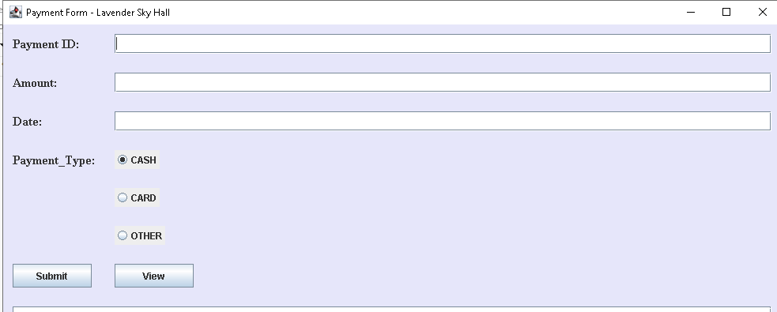
Code Menu.java:
package wedding_hall_management_system;
import javax.swing.*;
import javax.swing.table.DefaultTableModel;
import java.awt.*;
import java.awt.event.ActionEvent;
import java.awt.event.ActionListener;
import java.sql.Connection;
import java.sql.PreparedStatement;
import java.sql.ResultSet;
import java.sql.ResultSetMetaData;
import java.util.Vector;

public class MenuForm extends JFrame implements ActionListener {
JFrame frame=new JFrame();
JPanel panel=new JPanel();
JTextField menu_id=new JTextField();
JTextField menu_course=new JTextField();
JButton saveB=new JButton("SAVE");
JButton view=new JButton("VIEW");
JLabel menuID=new JLabel("MENU_ID");
JLabel menuCourse=new JLabel("COURSE:");
JLabel menuItem=new JLabel("CUISINE:");
JComboBox<String> menu_item = new JComboBox<>(new String[] {
"DESI", "CHINESE", "AMERICAN", "ITALIAN","KOREAN","JAPANESE", "MIXED","OTHER"});
private DefaultTableModel table3=new DefaultTableModel();
private JTable MenuTable=new JTable(table3);
JScrollPane scroll = new JScrollPane(MenuTable);
Connection conn;

public MenuForm() {
setTitle("Booking Form - Lavender Sky Hall");
setSize(1000, 1000);
setLocationRelativeTo(null);
setDefaultCloseOperation(JFrame.DISPOSE_ON_CLOSE); // Only close this window

getContentPane().setBackground(new Color(230, 230, 250));
setLayout(new GridBagLayout());
GridBagConstraints gbc = new GridBagConstraints();
gbc.insets = new Insets(15, 15, 15, 15);
gbc.anchor = GridBagConstraints.WEST;

Font labelFont = new Font("Serif", Font.BOLD, 16);

gbc.gridx = 0;
gbc.gridy = 0;
menuID.setFont(labelFont);
add(menuID, gbc);

gbc.gridx = 1;
menu_id.setPreferredSize(new Dimension(200, 25));
add(menu_id, gbc);

gbc.gridx = 0;
gbc.gridy = 1;
menuCourse.setFont(labelFont);
add(menuCourse, gbc);

gbc.gridx = 1;
menu_course.setPreferredSize(new Dimension(200, 25));
add(menu_course, gbc);

// Booking Type
gbc.gridx = 0;
gbc.gridy = 2;
menuItem.setFont(labelFont);
add(menuItem, gbc);

gbc.gridx = 1;
menu_item.setPreferredSize(new Dimension(200, 25));
add(menu_item, gbc);

// Submit button
gbc.gridx = 0;
gbc.gridy = 3;
saveB.setPreferredSize(new Dimension(100, 30));
saveB.addActionListener(this);
add(saveB, gbc);

gbc.gridx = 1;
gbc.gridy = 3;
view.setPreferredSize(new Dimension(100, 30));
view.addActionListener(this);
add(view, gbc);

MenuTable.setFillsViewportHeight(true);

gbc.gridx = 0;
gbc.gridy = 4; // next free row
gbc.gridwidth = 2; // span both columns
gbc.weightx = 1;
gbc.weighty = 1;
gbc.fill = GridBagConstraints.BOTH;
add(scroll, gbc);

setVisible(true);
}

@Override
public void actionPerformed(ActionEvent e) {
String id = menu_id.getText().trim();
String course = menu_course.getText().trim();
String items = menu_item.getSelectedItem().toString();

if (id.isEmpty() || course.isEmpty()||items.isEmpty()) {
JOptionPane.showMessageDialog(this, "Please fill in all fields.");
} if(e.getSource()==saveB) {
try {
conn = WeddingHall.getConnection();
try( PreparedStatement checkUser = conn.prepareStatement("SELECT MENU_ID FROM MENU WHEE MENU_ID= ?")){
checkUser.setString(1, id);
ResultSet rs = checkUser.executeQuery();
if (rs.next()) {
JOptionPane.showMessageDialog(null, this, "ID already exists.", 0);
}
}
try(PreparedStatement insertStmt = conn.prepareStatement("INSERT INTO MENU(MENU_ID,MENU_COURSE,CUISINE) VALUES (?, ?, ?)"))
{
insertStmt.setString(1, id);
insertStmt.setString(2, course);
insertStmt.setString(3, items);
insertStmt.executeUpdate();
JOptionPane.showMessageDialog(null, this, "Menu added successfully!", 0);
dispose();
new MainMenu();
}

}
catch (Exception ex) {
JOptionPane.showMessageDialog(null, this, "Error adding menu: " + ex.getMessage(), 0);
}
}
if(e.getSource()==view) {
try (PreparedStatement selectStmt= conn.prepareStatement(
"SELECT * FROM Menu_view");
ResultSet rs = selectStmt.executeQuery()) {

ResultSetMetaData md = rs.getMetaData();
int cols = md.getColumnCount();

// Build column list
Vector<String> colNames = new Vector<>();
for (int i = 1; i <= cols; i++) {
colNames.add(md.getColumnName(i));
}

// Build rows
Vector<Vector<Object>> rows = new Vector<>();
while (rs.next()) {
Vector<Object> row = new Vector<>(cols);
for (int i = 1; i <= cols; i++) {
row.add(rs.getObject(i));
}
rows.add(row);
}

table3.setDataVector(rows, colNames); // instant refresh

}

catch(Exception ex) {
JOptionPane.showMessageDialog(null, this, "Error viewing menu: " + ex.getMessage(), 0);

}
}
}

public static void main(String[] args) {
MenuForm menuobj=new MenuForm();

}
}
OUTPUT:
